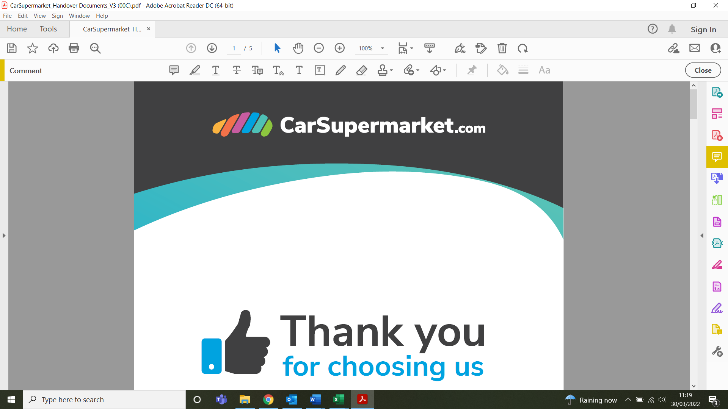

This privacy policy sets out how CarSupermarket.com uses and protects any information that you give to us when you use this website or otherwise interact with us through any channel including over the phone, in our showrooms, through our customer services, servicing departments, social media or otherwise.
When we refer to We, Us or CarSupermarket.com, we mean Motor Depot Limited whose registered office is at Bridge Haven One Saxon Way, Hessle, HU13 9PG and registered in England and Wales under company number 04316950. Within Motor Depot we have the following trading styles:
- CarSupermarket.com
- CarSupermarket.Finance
- Best Car Buyer
- Interestfree4cars

CarSupermarket.com may change this policy from time to time by updating this page. You should check this page regularly to ensure that you are happy with any changes. If we propose a significant change, we will notify you by email and will otherwise post an alert that our policy has changed on our website.

Information That We Collect
Depending on the relationship CarSupermarket.com have with you, we will collect and process some or all the following personal information about you: -
- Information that helps us identify you and enable us to contact you. This might include your full name, address, contact telephone number, email address, date of birth and proof of identity such as passport, driving licence and National Insurance Number
- Information to help us assess credit worthiness and to help you apply for finance. The information we process for this purpose will be determined by our finance partners but is likely to include things like marital status, current monthly payment information and residential status, length of time at address and previous addresses
- Information about the vehicle you are interested in (Make/Model/VRM)
- Financial information including whether you wish to part exchange a vehicle and, if so, information about the vehicle you propose to exchange (e.g Make/Model/VRM/Mileage/VIN/registration), your salary, financial commitments and disposable income
- The finance company you are currently engaged with (if any)
- Dates for end of current vehicle contracts
- Your bank details including account number, sort code, credit/debit card details
- Information about your employment status including job title, employer name, previous jobs, previous employers, salary, previous salary
- Your driving licence and National Insurance Number should we need to check the validity of your licence
- Your name, address, email address, driving licence and e-signature if you would like to test drive a vehicle
- Your name, address, email address, driving licence and National Insurance Number should you require a courtesy car to be provided to you
- Your name, address, telephone number and vehicle registration if we need to arrange vehicle recovery services or vehicle repair is required
- Call recordings and CCTV footage captured when you are on our premises
- Your contact preferences
- Information about your interactions with us and which you otherwise provide to us
- Feedback you provide to us in response to our customer satisfaction surveys

Where we collect your personal information from

CarSupermarket.com will hold personal information about you from a number of sources including:
- When you complete enquiry forms on our various websites or when you otherwise interact with us by phone, email, post or otherwise
- When you visit our showrooms
- When you visit our websites, we will automatically collect certain information about you (see our cookies policy for more information)
- Third party lead generation websites such as Auto Trader, Motors.co.uk, CarGurus

The purposes we will process personal information for
CarSupermarket.com will use personal information about you for the following purposes: -
- To respond to and fulfil any request that you make through this website or otherwise. This might include, for example, if you request a brochure, a test drive, a vehicle valuation, to book a service or to provide you with information requested about our range of products and services
- To contact you with information about the products and services we provide (if you request)
- To propose a new vehicle at the end of the current contract
- To help you arrange finance
- To manage our relationship with you
- To fulfil the contractual commitments, we make to you
- To respond to and resolve any complaint you may have from time to time
- To process payments and if necessary, collect arrears
- To arrange collection or delivery of your vehicle where applicable
- To monitor, assess and improve, the level of customer service we provide, and our website
- To enable us to carry out analysis on sales and enquiries for business reporting
- To conduct customer satisfaction surveys
- To personalise our interactions with you (please refer to our cookies policy for more information)
- To detect or prevent unlawful, malicious or offensive activity
- To contact you about safety or quality issues relating to your vehicle
- To contact you about updates or changes to our business that may affect you e.g. if we open a new branch or close a branch that you are associated with
- To remind you about important dates including service or MOT deadlines and those relating to the end of finance agreements
- To arrange a vehicle recovery service or vehicle repair
- To arrange supply of a courtesy vehicle to you
- To comply with law and to exercise or defend our legal rights
- For health and safety purposes
- Where you have given your consent, we will contact you for marketing purposes. Depending on your preferences, we might contact you by phone, email or SMS (including WhatsApp)
What legal basis do we rely on to process your information?
Data protection law sets out a number of conditions which organisations can rely on in order to lawfully handle personal information. The conditions we rely on are as follows: -
Legitimate interests
The law permits us to handle your personal information where necessary in our legitimate interests provided that this isn’t outweighed by your interests. Many of the purposes we handle your personal information, described above, fall into this category as they are essential activities which enable us to run our business efficiently and effectively for example, enabling us to use third party service providers and to monitor, review and improve the services we provide to you and your experience when you visit our website.
CarSupermarket.com also rely on the legitimate interests basis for processing to contact you to remind you about important safety and quality issues relating to your vehicle including to remind you about service and MOT due dates. This is important to help ensure that you comply with legal requirements and also maintain the quality of your vehicle. We will also contact you to remind you about the date your finance agreement is due to end. If you would prefer that we didn’t remind you of these dates, you can let us know anytime by contacting our Data Protection Officer on the details below.
CarSupermarket.com also rely on this processing ground to help us ensure that we communicate with you about products and services, that you are most likely to be interested in, and in the way that you are most likely to want to communicate with us. We will also use this basis to inform of you of changes to our business that may affect the services we offer. We may, if necessary, also use your information to defend our legal rights, to obtain legal advice, to monitor our premises and to manage any complaint that you might have. We ensure that your rights and interests are protected when we do this.
Consent
You have a choice about how you receive our marketing information. We will not use your personal information for marketing purposes unless you have indicated that would like to hear from us. You can change your contact preferences at any time by unsubscribing from any email received or by contacting our data protection officer on data.protection@carsupermarket.com
Performance of a contract
Where you transact with us to buy vehicles or parts or to book a service or MOT, we will use your personal information so that we can fulfil our part of the contract e.g. to provide the services, sell you a car and take payment from you. Where we need personal data to perform our contract, if you do not provide it, we will not be able to provide the services to you.
Required by law
CarSupermarket.com will, if required by law, disclose your personal information for example in response to a Court Order. We will disclose your personal information if requested by a law enforcement agency or where we believe it is necessary to investigate, prevent, or take action regarding illegal activities, suspected fraud, situations involving potential threats to the physical safety of any person, non-compliance with of our Terms and conditions, or as otherwise permitted or required by law and consistent with legal requirements.

Who we share your personal information with
In order to manage our business effectively, and to provide the services we offer to you, we will need to share your personal information (or some of it) with certain third parties. CarSupermarket.com will not share your personal information unnecessarily and will always ensure that all third parties who process your personal information on our behalf, have entered into an appropriate written contract with us, are required to process it in accordance with our instructions, and have appropriate measures in place to protect it.
The types of third parties CarSupermarket.com will share your personal information include: -
- Delivery companies who help us deliver and collect vehicles from time to time
- IT service providers who help us manage our IT infrastructure including CCTV and call recordings
- Finance companies and brokers where you want to obtain finance to facilitate your purchase
- Debt collection agencies should there be an outstanding debt
- Marketing agencies who we use to support our marketing activities
- Aftercare services such as our warranty partners, recovery agents and repair garages
- Courtesy car providers
- Legal and other professional advisors who support our business
- Social media companies and other third parties we work with to support our targeting activities
- Insurers
- Government departments and the DVLA
- Law enforcement agencies e.g. Police
- Private car parking management companies
- Customer satisfaction partners
Advertisers
When you consent to marketing with us you agree that your personal details and information that you provide may be shared with our advertisers who may then match and analyse data to provide personalised marketing of products and services. Contact information such as name and email address may be shared as well as event data such as website visits and online purchase data that provides information about online and offline events. The contact information data may then be matched with event data and then used for targeting and delivering advertisements. Our advertisers may also use the data collected to monitor the customer journey and use this information to improve future services.
Companies in our group of companies

We are part of a group of companies and will, from time to time share personal data with other companies in our group. This might be for reporting purposes, to use company IT infrastructure or to otherwise ensure that we run our business effectively.
CCTV
CarSupermarket uses CCTV to protect company owned property and to provide a safe and secure environment for employees and visitors to its premises. CarSupermarket has a legitimate interest to collect personal information via CCTV recordings for the following purposes:
- Preventing or detecting crime.
- Identifying and prosecuting offenders.
- Monitoring of the security of the CarSupermarket premises.
- Ensuring that health and safety rules and CarSupermarket procedures are being complied with.
- Providing evidence of health & safety breaches in the event of accidents resulting in internal investigations and post incident communications and safety training.
- Assisting in the investigation of incidents involving staff or members of the public.
We will only disclose CCTV recordings to other third parties only in accordance with the above purposes for which they were originally retained.
Access to CCTV recordings within CarSupermarket is restricted to the operators of the CCTV system and to managers who are authorised to view them. Viewing of CCTV recordings will take place in a restricted area and other employees will not have access while the recordings are being reviewed.
Footage will be automatically overwritten between 14 and 28 days after it has been recorded. Recordings may be retained for longer where there the Company has an overriding legitimate interest (e.g. as part of an investigation) or there is a legal obligation (e.g. criminal offence).
For any questions relating to CCTV please contact data.protection@carsupermarket.com.

How we keep your personal information secure
CarSupermarket.com takes your privacy seriously and takes every reasonable measure and precaution to protect and secure your personal data. CarSupermarket.com work hard to protect you and your information from unauthorised access, alteration, disclosure or destruction and have several layers of security measures in place, including SSL, TLS, restricted access, IT authentication, firewalls, anti-virus and anti-malware.

International transfers of personal information
CarSupermarket.com may occasionally share your data with third parties outside the European Economic Area (EEA) and the UK.
Whereas in the EU and UK, we implement a high standard of data protection law, some parts of the world do not implement such stringent laws. As a result, if we do send personal information overseas, we will make sure that appropriate safeguards are in place to ensure it is protected in accordance with UK data protection law. These might include: -
- Sending personal information only to countries that European Authorities have indicated have adequate data protection laws in place e.g. Canada or Switzerland
- Putting in place contracts with the recipient containing terms which the European Authorities have approved as providing adequate protection.

How long we keep your personal information for
CarSupermarket.com will keep your personal information for as long as we need it to provide the services and products you request from us. We may also keep it to comply with our legal obligations, to resolve complaints and to enforce our rights. As a result, the length of time that we keep your information for will vary depending on the purposes for which we have it. In any event, we will review what information we need on an ongoing basis and will only retain it for the minimum amount of time that we need it.

Your rights
As data subject, data protection laws give you a number of rights in relation to your personal information. You have the right to access your personal information, to have your personal information corrected or erased (right to be forgotten). You have the right to restrict the processing of your personal information, to have it transferred to a third party in a commonly structured format. You also have the right to object to the processing of your personal information. If you object to your personal information being processed for marketing purposes, we will comply with that request. Where you object to other processing, we will consider your request carefully. We do not want to handle your personal information for purposes you do not want us to however, you should be aware that the above-mentioned rights are not absolute and, in some circumstances, may not apply.
If you want to exercise any of your above-mentioned rights please contact us at by email at data.protection@carsupermarket.com or in writing Bridge Haven One Saxon Way, Hessle, HU13 9PG.
You can update your personal information at any time by contacting us as above. We will also take steps to update your personal information (e.g. update your address), if CarSupermarket.com become aware that it has changed.
You also have the right to lodge a complaint with the supervisory authority. To do this, you can contact The Information Commissioner’s Office through their website at www.ico.org.uk, by phone on 03031231113 or in writing to Wycliffe House, Water Lane, Wilmslow, SK9 5AF.

Cookie Policy
Please click on the following link to see our Cookie Policy
For more information about cookies visit https://www.aboutcookies.org.

